UNIVERSITY OF HELSINKI / FACULTY OF SCIENCE  MASTER’S PROGRAMME IN GEOLOGY AND GEOPHYSICS  Thesis agreement | 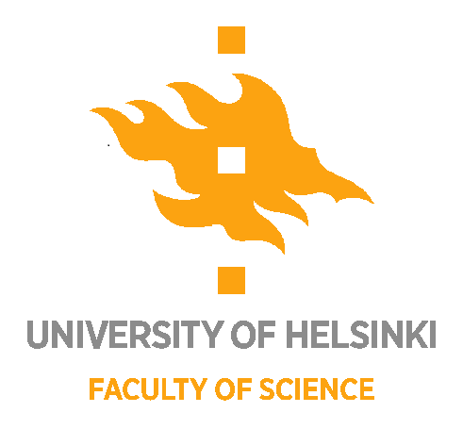

Student name:
Student number:
Email and telephone:

Please fill in the fields below. All text in italics is intended to be edited.

Supervision (supervisors and supervisory arrangements):
Supervisor/supervisors (UH – at least one supervisor from the Department of Geosciences and Geography is required)
Supervisors(s) from collaborating organization(s) (if applicable)

Supervisory arrangements:
Short description of e.g. how often meetings will occur, how feedback is given and used. Describe also how the student and supervisor will decide the thesis is ready for grading. See instructions here.

Topic of the thesis:
Title of the work.

Aims of the thesis:
Describe the main aims and research questions of the work.

Research field, materials and methods:
Describe or list the research field.
Describe the research area.
Describe the materials and methods.

Preliminary timetable (text in italics can be modified according to needs)
The time available for the MSc thesis is calculated as follows: (30 CP -> 810 hours -> approx. 20-22 full working weeks, or 5-6 full working months).

Note: if the MSc thesis project receives salary or fee, the practical parts of the work can be longer than stated below.

The student and supervisors have agreed upon the following breakdown of time to complete the main stages of the work:

The thesis work will begin on: xx/xxxx (give the date to the nearest month)

Orientation to the topic (~40-80 h.)
Reading literature on the topic, writing the MSc thesis agreement, idea forming for the introduction.
Gathering of materials/fieldwork (~40-160 h.)
The duration of this stage depends on the topic, longer durations are taken into account in planning the duration of later stages to balance the overall workload.
Analysis/ lab work/ programming or modelling work (~40-240 h.):
The amount of time may vary depending on the methods used, e.g. lab work, GIS analysis, models.
Drafting the materials & methods section (~20-80 h.):
The student writes the first draft of the materials & methods section of the thesis based on observations during field, laboratory or modelling work.
Visualization and writing of results section (~160-240 h.):
Statistical analysis, production of graphs, maps, tables, writing the results section and considering the main interpretations.
Writing the discussion section (~160-240 h.):
Write the discussion section to demonstrate your understanding of the results in a logical and convincing way.
Finalizing the introduction and conclusions sections, finalizing the materials & methods section (~40-80 h.):
The introduction is modified to fit with the results and discussion sections. The adjusted main goals of the study are written in detail, the conclusions are added at the end of the document.
Technical finalizing of the work (~20-40 h.):
The whole thesis is checked against the guidelines to ensure correct use of fonts, graphics, tables and references. Accessibility requirements are taken into account.

The thesis is intended to be completed on: xx/xxxx (give the date to the nearest month)

Research resources (collaborating partners, materials, equipment), spaces and funding:
Describe where the practical work will be done, what equipment will be used and how collaborating partners will assist.

Use of data and publication:
Describe here the conditions for access and use of data used in the thesis during and after thesis completion. For example: “Data generated during the project will be available for use by the student until XX.XX.XXXX. The supervisor(s) can also use the data during this period on a case-by-case basis. An MSc thesis will be produced from the data by XX/XXXX, which will be published in E-thesis. The student can be included as a co-author on subsequent scientific publications that feature the data, pending agreement with the supervisor. The data may also be used in PhD theses and in other relevant contexts. In such cases, the contributions of the student and supervisors must be appropriately acknowledged.”

Supervision checklist
Supervisor’s and supervisee’s rights and responsibilities. All points must be checked.

☐ We have consulted the University of Helsinki’s instructions for duties of the supervisor and supervision plan and discussed these.
☐ We have consulted the processes related to the MSc thesis work.
☐ The student has familiarized themselves with the grading matrix.
☐ The student and supervisor(s) understand they must agree the thesis is ready prior to submission for grading.
☐ We have discussed the student’s personal expectations of the supervision.
☐ The student has been given the possibility to describe any challenges (related to learning, skills, personal life situation etc.) that may influence progression in the work.
☐ We have discussed the principles of good scientific practice and ethical guidelines.
☐ We have reviewed the University of Helsinki guidelines concerning use of AI.
☐ We have reviewed the University of Helsinki guidelines concerning digital accessibility.
☐ Data handling in the thesis work is in line with the University of Helsinki research data policy.

Circumstances in which the thesis agreement may be terminated immediately:
Scientific deceit, inappropriate behaviour, actions that threaten safe co-working and adherence to good scientific practice.

Period of validity
The thesis agreement is valid until xx/xxxx (give the date to the nearest month)

Date and signature:

Date:

Supervisor(s): Student:

Distribution: student, supervisor(s), student services

