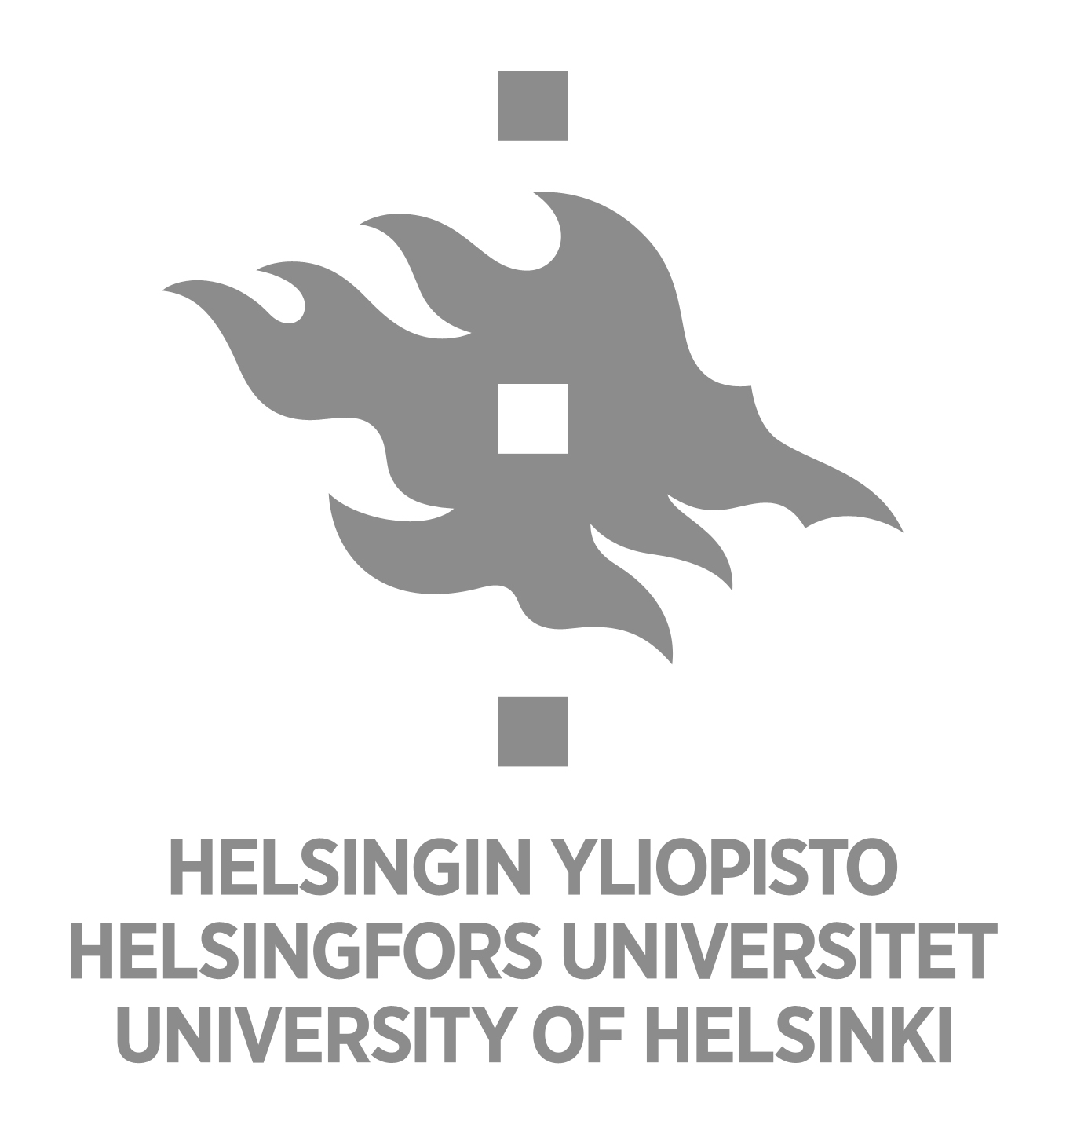

Master`s thesis
Master´s Programme in Geology and Geophysics
Study track:

TITLE

Name of the author
Date

Supervisor(s):

UNIVERSITY OF HELSINKI
FACULTY OF SCIENCE
DEPARTMENT OF GEOSCIENCES AND GEOGRAPHY

P.O.BOX 64 (Gustaf Hällströmin katu 2)
00014 University of Helsinki

